電器規格  1) 使用電源：請參閱儀器背面電壓規格。(AC100V~240V 50/60 Hz)  2) 顯示器：0.56” LED， 3 ¹/₂ 位數。  3) 輸入阻抗：10¹² 歐姆。  4) 耗電：大約 2 瓦。  5) 控制信號規格：Normal Open.  6) 控制啟動指示：LED 亮燈指示。  7) 測量範圍：-1999 ~ +1999 mV。  8) 外部校正：無。  9) 設定控制範圍：-500~ +500 mV。  10) 解析度（讀值）：1 mV。  11) 精確度（校正後誤差）：±(1 mV +2位)。  12) 外觀尺寸：150 ×85 ×40 mm (5.9 × 3.4 × 1.6 inch)   ORP 電極置於水中不可超過電極帽高度。  電極輸入插座除了 ORP 電極外,不可插入其它插頭。  控制器使用時請盡量遠離電子式安定器電燈,及不要使  用同一電源插座,避免干擾本儀器。  3 2011-ORP-2203C |  | ORP 監控器使用說明書  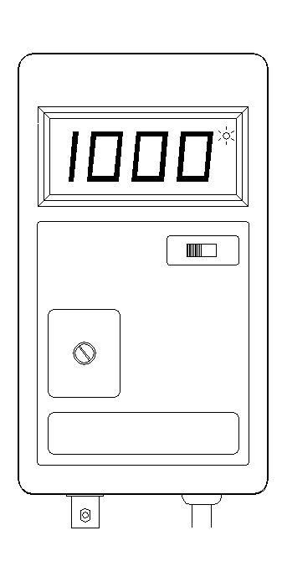  使用本ORP監控器前，  請詳細閱讀本說明書，正確使用及確保測試值的準確度
  經銷商

各部名稱說明  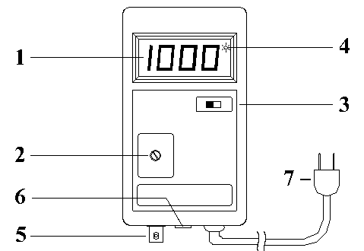  操作說明  - 依電壓規格指示接上電源。  2) 將 ORP 電極裝入ORP 輸入端 (BNC接頭插入後，右轉到底)。  3) 將功能開關位置切到 " SET " 設定位置。(此時控制信號自動關閉)  4) 利用小型 "─" 字起子調整 SET 的旋鈕，使顯示的數字到達到所需要設定的ORP 值。設定完後請將開關切回 " ORP " 測量位置。(測試值低於設定值時會啟動控制信號)  5) 將 ORP電極以蒸餾水稍作清洗後放入所要測量控制的水中。  註：本氧化還原控制器，出廠前已經模擬電極信號校正妥，使用時不需再校正。(如果需要校正，請送回工廠作校正)  清潔保養  1) ORP 電極置於水中不可超過電極帽高度，(如為可填充式電極，置於水中不可超過填充孔高度，以免水進入電極內而損壞)且定期(2~ 3星期)以軟毛牙刷輕刷清洗感應頭所附著之藻類或雜質，以確保測量的準確性。不用時，電極請置於有3莫爾 KCL保存液之封套內，若有結晶乃屬正常現象。  2) ORP 電極為一精密之玻璃製品，請勿敲擊，以免內管玻璃破裂損壞。電極請勿用手及布類或酒精擦拭電極前端白金感應頭，以免損壞。  3) 本儀器僅供室內使用。  1 |  | 備註  1) 為保護所控制設備不受頻繁啟動而損壞，設有延遲啟動功能。  2) 餵食前、後、白天、晚上及pH值高低都會影響其氧化還原電位高低。  為什麼要測氧化還原電位值ORP (Oxidation Reduction Potential)  以容易了解的水族觀念來說，氧化還原電位值 ORP 的高或低，代表水中可以氧化掉有毒阿摩尼亞及亞硝酸鹽能力的大小(但同時也會氧化其他物質)! 簡單來說，魚缸污染物質較多時，氧化還原電位值相對較低；魚缸污染物質較低時，氧化還原電位值相對較高。  ◎ 一般魚隻飼養缸氧化還原電位可以從 200～500mV(視過濾系統與溶氧效率而定)。  ◎ 飼養良好的海水軟體缸：  其氧化還原電位參考值約在 360(早晨;剛開燈)～450mV(傍晚;剛熄燈後及之後一段時間)。  ◎ 飼養良好的水草缸：  其氧化還原電位參考值約在 250(早晨;剛開燈)～400mV(傍晚;剛熄燈及之後一段時間)。(魚隻飼養量多時會較低，飼養量少時會較高)  ◎ 特別設計使用的除硝酸(denitrification)過濾槽：  其氧化還原電位參考值約在 -190～50mV (切記勿低於 -190，以防過度厭氧反應產生有毒的硫化氫)。  污染度較高的水族缸中較常見情形  污染度較高的水族缸中較常見情形是氧化還原電位值過低，而不容易升高。調升水中的氧化還原電位值常見方法可以採用:  使用臭氧機添加臭氧，增加使用蛋白質除沫機，提升水中溶氧效率(如大量有效的滴流過濾、溶氧錐等)，添加ORP調升液等方法。  2
  1) ORP 顯示器 | 5) ORP 電極 BNC 接頭
  2) 設定值調整鈕 | 6) 3.5mm 控制輸出座 (Normal Open)
  3) ORP/SET 測量與設定開關 | 7) 電源插頭
  4) 啟動控制指示燈

GENERAL SPECIFICATION  Power Supply：AC100V ~ AC240V  Measurement：-1999 to +1999 mV  Resolution：1 mV  Accuracy at 25°C：±(0.1%+ 2 digits) after calibrating  Impedance：1012 ohms  Set Range：-500 to +500 mV  Calibration Knob：None external  Relay Contact：5A for 240VAC  Control Output Voltage：Same as plug in AC voltage  Display：0.56" LED, 3 ¹/₂ digits  Operating Temperature：0 to 50°C (32 to 122°F)  Operating Humidity：Max. 90%  Power Consumption：Approx. 2 watts  Dimension：150 ×85 ×40 mm (5.9 × 3.4 × 1.6 inch)  Standard Accessories : Instruction Manual, Adjustment Sticker, Instrument Holder each one.  ORP electrode input BNC terminal can only connect with ORP electrode, it is not allowed to connect with any other electrode.  3 2011-ORP-2203C |  | OPERATION MANUAL  ORP CONTROLLER  Please read the attached instructions carefully before use.
  AFTER SERVICE CENTER

FRONT PANEL DESCRIPTION  OPERATING  1) Connecting AC power supply. (Make sure the correct voltage.)  2) Connecting the ORP electrode into the ORP input terminal socket.  3) Turn the ORP/SET switch to "ORP" position.  4) Take away the ORP electrode from storage bottle, and clean the electrode with distilled water, then place the electrode into the water.  REMARK: The controller is already calibrated (base on 25°C environment). It needs not to make calibration any more. Please contact with your dealer where you buy when the calibration is necessary to apply.  INSTRUCTION FOR CLEANING AND MAINTENANCE  1) The immersed level for electrode should not be higher than the electrode cap. (When use the refillable electrode, the level should be lower than filling open to avoid the water entering into the open and cause damage.) It had better cleaning the ORP electrode sensor with soft brush every 2-3 weeks to keep the test accuracy. Please keep the electrode in the storage bottle with 3M KCL buffer solution; the crystallization is normal for the keeping.  2) ORP electrode is accurate glass product, please do not knock it, and do not use finger, cloth and alcohol to clean it to avoid the damage.  1 |  | 3) There is protection "dead band" for delaying output control in “turn on” and “turn off” to avoid frequent switching.  4) Indoor uses only.  WHY SHOULS WE KNOW ORP (Oxidation Reduction Potential) RANGE  To realize it by easy understanding aquarium concepts, The high or low value of ORP shows higher or lower capacity which can oxidize toxic ammonia and nitrite in water( but also oxidize the other materials in water)! In short, more pollutants in fish tank, ORP value is relative lower; and is often higher for less pollutant situation.  ◎A well keeping coral reef aquarium  The reference reading of ORP could be between 360 (just lighted up) and 450mV (duration of switching light off)  ◎ A well keeping freshwater plant aquarium  The reference reading of ORP could be between 250 (morning or just turn the light up) and 400mV or even higher (evening or just turn the light off), (normally the higher ORP reading shows for lower fish population, and the lower reading shows for higher population. )  ◎The denitrifying reaction chamber or filter  The reference reading of ORP should be between -190 and 50mV. (to avoid produce the poisonous hydrogen sulfide in over reduction, the ORP value should not be below -190mV ).  THE COMMON SITUATION IN HIGHER POLLUTED AQUARIUM  The common situation is lower ORP value in higher polluted aquarium and the value is not easy to be shifted up. The common ways to take to shift the ORP value up: Use ozone generator, protein skimmer, effective trickle filter or oxygen tower to increase the dissolved oxygen in water, add additives to increase the oxidation potentials.  2
  1) Display | 5) Electrode BNC input terminal
  2) Set adjustment knob | 6) Control output socket (Normal Open)
  3) ORP/SET function switch | 7) Power plug
  4) Indicator of output in action

